

How to be included in

Orleton Village Magazine

This magazine will be published on the first day of each month on the Village Website: *www.orletonvillage.co.uk.* Notification of publication, together with a link, will be given on Nextdoor and Orleton Village Chat (Facebook)

Articles of general interest, club or association reports and advertisements for community events may be included without charge. Commercial advertisements are charged, dependent on size. (Rates available on request from: [orletonmagazine@gmail.com](mailto:orletonmagazine@gmail.com))

Small private sale advertisements may be accepted without charge if space allows

**Orleton Village Hall**

**Ideal venue for family events, parties, weddings, concerts, dances,**

**training courses, drama performance, exhibitions, classes and craft fairs.**

**Large hall (160 seating capacity) with proscenium stage, theatre lighting and sound system, electric piano, video projector and radio mike.**

**Additional small hall (50 capacity)**

**Superb five star rated kitchen, cutlery and crockery. Large car park.Free Wi-Fi**

**Also tables, chairs and marquee available for hire for garden parties**

**For bookings /quotations: bookings@orletonvillage.co.uk**

**Tel 01568 780583**

All content is accepted at the discretion of the editorial team. Articles that are disrespectful or prejudicial will not be accepted.

Copy should be submitted as Word or PDF files. If hard copy is submitted there may be a charge for scanning and input.

All copy must be accompanied by the name, address and telephone number of the author, although this will not be included unless incorporated into the article.

Articles for publication should be emailed to: orletonmagazine@gmail.com by the 20th of the month prior to desired publication

**Editorial**

**Orleton Village Hall**

**Ideal venue for family events, parties, weddings, concerts, dances,**

**training courses, drama performance, exhibitions, classes and craft fairs.**

**Large hall (160 seating capacity) with proscenium stage, theatre lighting and sound system, electric piano, video projector and radio mike.**

**Additional small hall (50 capacity)**

**Superb five star rated kitchen, cutlery and crockery. Large car park. Free Wi-Fi**

**Also tables, chairs and marquee available for hire for garden parties**

**For bookings /quotations: bookings@orletonvillage.co.uk**

**Tel 01568 780583**

February's meaning comes from the ancient Roman festival of purification called Februa, and is generally considered the last month of Winter, although often March has other ideas!

February is a bit of a doldrum – December has Christmas. January started with the New Year celebration. In March we start the buildup to Easter.

Poor old February does not appear to have much going for it but look closer. The snowdrops are already blooming. The green shoots of daffodils are already poking through the frozen ground ready to burst forth in glorious golden display later in the month together with crocuses of many colours.

Although February may be considered the last month of Winter, it may also seem to be the first month of Spring.

If you have content for the Magazine please send it to us. (Details on previous page)

We also welcome your comments and suggestions for improving our magazine

We will be publishing the following content:

* Reports of local activities
* Free adverts for events open to the community.
* Paid adverts from local businesses offering local services
* Free private for sale adverts

The last two categories will be limited as we do not want to swamp the magazine with advertising. Our production costs are low so only a few select adverts from local services or sale items will be accepted for publication.

**Orleton Evergreens**



**Folk at the Boot**

Not just folk but all genres

of music

Performers always welcome



It's always 2nd Thursday of the month at 8.00pm

Our February meeting is on 26th, 2:30pm, Orleton Village Hall when we have one of our favourite entertainers, Steve Hollinghurst, joining us to deliver ‘Popular Songs’.

The subs remain at £12 for the year with the revised £4 entry, £6 for visitors.

Contact Sue Turner

Sue.a.turner@gmail.com

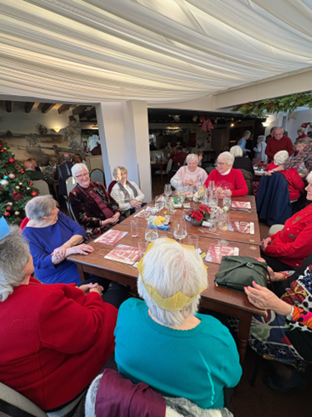





Orleton Art Group

Are you artistic or do you fancy trying your hand at painting and drawing? If so come and join us. We meet Wednesday afternoons from 2.00 until 4.30pm at Yarpole Village Hall.

For more information please email Larry Turner, laurencepturner@gmail.com

or Geoff Trotter, geoffrey.a.trotter@gmail.com

Or telephone Larry on 01584 831324

Apperley Recreation Ground

On Sunday 18th January, the new pavilion on the Apperley Recreation Ground - the Rec – was officially opened by Roger Williams, one of the many volunteers who work tirelessly to keep the Rec in such great condition. In Roger’s case, he has been working on the Rec for over 40 years and has spent 1000’s of hours in our ever faithful tractor mowing acres of grass.

It was fantastic to see so many villagers at the opening, especially as the weather was not kind to us.

And it was especially heartwarming to welcome some old faces who had been involved in the purchase and creation of the rec from the very beginning, when the 11 acres of land were acquired from Fred and Margaret Apperley at a very favourable rate in 1988.

For at least the last 15 years it had been the aim of ORA to replace the old pavilion, which had been situated on the Apperley Recreation Ground for over 30 years, and was already second hand when it arrived in 1990. It had fallen into a very poor state of repair, and the wish was to replace it with a new, modern, fit for purpose pavilion.

When the current committee came together, in 2023, we were advised that the building may have to be demolished, if, by, 2028, we hadn’t had it renovated as each winter it was further deteriorating.

Had that happened, then we would have faced a considerable bill to demolish and make good – money we didn’t have.

So, we prioritised fund-raising and set about raising the £110,000 that we had been advised that we would need to complete the project.

Over the next two years – and after a lot of letter writing – we raised the money and we would like 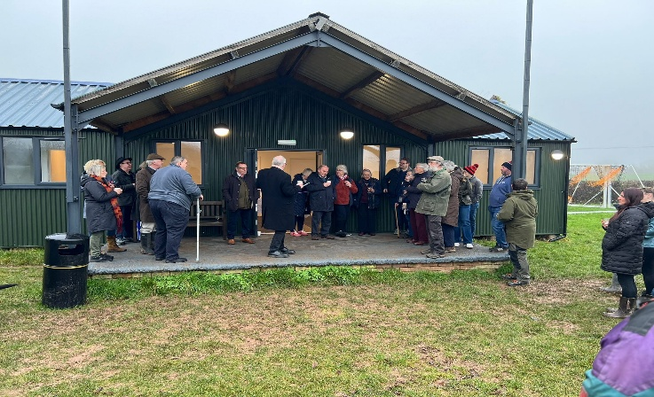to publicly thank the following organisations for their very generous grants

 o Clive Richards Foundation

o Herefordshire County Council that allocated a portion of the S106 monies

o Garfield Weston Foundation

o CHIC (Communities and Housing Investment Consortium) Social Fund

o Kingspan’s Social Fund

o Orleton Young Farmers

o Richards Castle Soap Box Derby Committee

o Orleton and District Junior Football Club

We had been joined, and hugely supported, by Oli Smith, an architect, and Andrew Houston, a project manager from HCC – both Oli and Andrew worked tirelessly pro bono to help us – it is no exaggeration that the Project would have been so much more difficult without them

We tendered the work and with Andrew and Oli’s help, chose Sam Morris to do the work. Sam and his team were fantastic to work with, they went beyond what they were required to do, and they brought the build within budget – no easy task in today’s environment.

We would also especially like to thank Claire Morgan, Claire Smith and Bel Beaumont who gave so much to this project.

And on January 18th, all the hard work came together as we opened the pavilion, which we hope will become a much used and  much loved village resource for the next 40 years.

**Orleton WI**

WI had a demonstration of the art of decoupage by our President Sue Copson.

Decoupage the art of decorating objects with paper cutouts began in 12th century China evolving from Siberian felt art, and spread to Europe by the 17th century becoming a

popular imitation of expensive lacquerware called "lacca povera". It flourished in 18th century French and English courts and the Victorian era as a fashionable hobby, gaining widespread appeal with printing advancements and saw a revival in the 1960's DIY movement.

Sue brought along some of the many items she had beautifully decorated including Christmas decorations,

vases, lamps and a small table showing how versatile this craft can be.

Orleton WI members then had the opportunity to try their hand at this craft, creating pretty vases using jam jars and paper napkins. Our thanks go to Sue for showcasing this enjoyable craft.

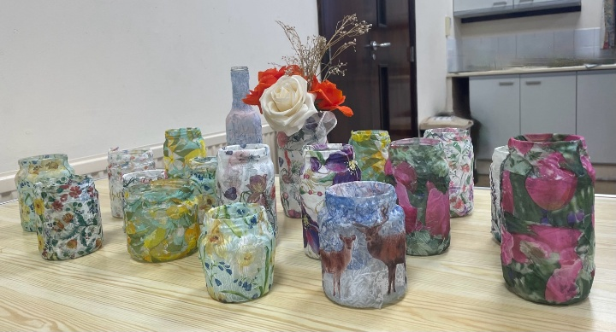

**Forthcoming Event**



On Monday February 9th at 2.30pm, we welcome Amy Johnson from St Michaels Hospice Hereford, who will give us with an insight into the wonderful palliative care services they provide.

Visitors are always welcome and on this occasion we are inviting everyone to bring along a donated item for the hospice to sell for their



funds. Ideas include a household item, a book or item of clothing; all will be gratefully received.

We have a raffle; £1 a ticket and free refreshments. Visitors £4.

For further information please contact Sue Copson (President) on 01568 780956







**Orleton Coffee Morning needs you!**

Orleton holds a weekly coffee morning at our village hall on a **Wednesday morning at 10.30am–12 noon.**

We offer homemade bakes, hot drinks, and a friendly informal place to meet and chat.  
  
We would love to welcome a few more folk onto our team of helpers.

***Do you have a favourite bake you may like to share with us?***

***Enjoy meeting and greeting folk, and maybe you would like to help at a session on an occasional basis?***

**WE WOULD LOVE TO HEAR FROM YOU!**

*Please contact our Chair Cathy Hardwick via email at cathy.hardwick@hotmail.co.uk*

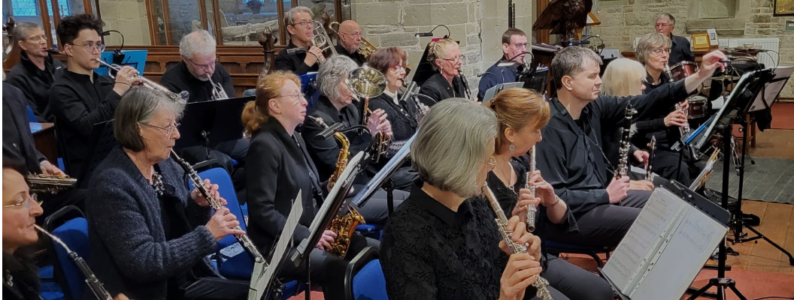

Ludlow Concert Band

By popular request this impressive band is to return to Orleton Village Hall on 7th March with their wide repertoire of classics, big band numbers and popular music.

Tickets inc light refreshment from Orleton Village Shop & post Office £10 ( £12 on the door)

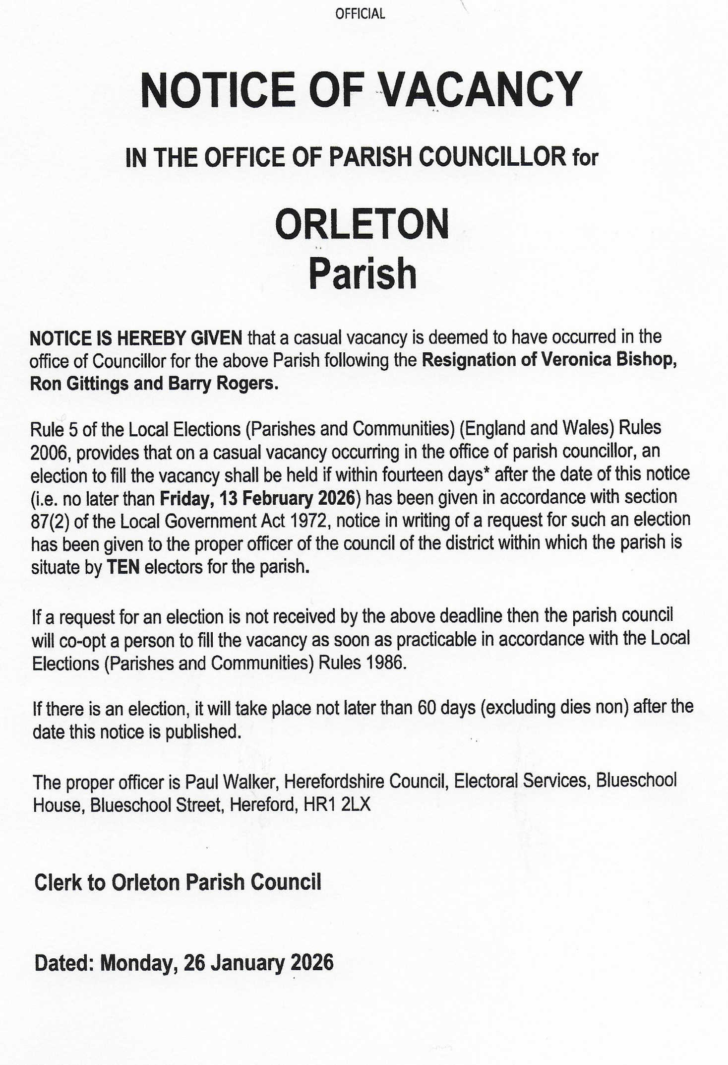



**Safer Neighbourhood Team**

**Did you know we have a specialist team that deals with Rural Crime?**

**Types of Rural Crime:**

**Acquisitive Crime:**Acquisitive crime in rural areas often involves the theft of high-value equipment and machinery, such as tractors, quad bikes, and farming tools. Other offences in this category include the theft of fuel and livestock

**Wildlife Crime:**Includes hare coursing, hunting with dogs, poaching, and interference with protected species such as bats, badgers and birds of prey.

**Equine and Livestock Crime:**Such as theft of animals, (horse) tack theft and livestock worrying.

**Heritage Crime:**Crimes that damage heritage assets, including lead theft from churches, damage to monuments, and illegal metal detecting.

The rural crime team work closely with safer neighbourhood teams like ours, to offer crime prevention advice and reassurance visits to our communities.

**PCSO Stephanie Harper 6440  
Police Community Support Officer | SNT Leominster  | West Mercia Police**

Enterprise Way, Leominster, Herefordshire, HR6 0LZ  
**Mobile:** 07773043483

**Direct Dial:** 01432 347217 **Ext.** 7723019

**Team mail**: [leominster.snt@westmercia.police.uk](mailto:leominster.snt@westmercia.pnn.police.uk)





Janet’s Jacket Potatoes

will be visiting Orleton Village Hall Car Park on

Monday 2nd February from 5.30 until 7.30 pm.

Select on the night or pre-order on the Facebook site

Should this prove popular it may become a regular event.

**Orleton Charity Quiz Nights**

**Teams of up to six members. 7.30 for a 8.00pm start**

**Pre-booking of tables at:**

**the Boot (01568 780228) and the Maidenhead (01584 831686)**

**is strongly advised**

**All proceeds go to support local organisations in Orleton Village or**

**recognised National Charities.**

**Special Event: John Robbins Memorial Quiz at Orleton Village Hall**

**on a Saturday evening. Watch for the date!**

February 10th Boot Inn

March 10th Village Hall

April 14th Maidenhead

May 12th Boot Inn

June 9th Village Hall







**Report from your County Councillor**

**Dan Hurcomb**

Congratulations to the committee and volunteers of the Recreation Ground on the opening of the new pavilion. A significant amount of time, effort and resource has gone into making it happen and I hope that it will become a cherished community facility in the years ahead.

The January Parish Council meeting was well attended given the topics up for discussion and I was pleased to be able to update residents on the progress that has been made on local issues over the past few months. Of particular interest was the proposed “flood alleviation scheme” which is now moving into a critical phase – I hope to be able to share more details in subsequent issues of this magazine.

Parish Councillors give up their time and energies for free to represent the interests of local residents and I would like to publicly thank former Cllrs Bishop, Gittings and Rogers for their dedication and hard work during their time serving the community. I hope that the vacancies their resignations have created will be filled quickly so the Parish Council can return to normal service as soon as possible.

On a final note, in December I was asked to put forward roads to be considered for the 26/27 Highways Resurfacing Program. I can confirm that I have put forward Green Lane, Tunnel Lane, B4362 from Comberton to the Shropshire boundary, The B4361 from Portway to Ashley Moor turn, and Leys Lane (Ashley Moor). The budget is finite so there is no guarantee these will be done but they will be inspected as part of the request.

As always if you have any concerns, issues or would just like a chat then please do get in touch.

Dan Hurcomb

[dan.hurcomb@herefordshire.gov.uk](mailto:dan.hurcomb@herefordshire.gov.uk)

07837726821

Open the Book 

Could you be a storyteller?

OtB is an exciting storytelling project where a group of people share Bible stories with the children in Orleton school on a Tuesday morning each fortnight. The stories are interactive and the children love to help deliver the 10–15-minute scripted Bible stories as part of Collective Worship.

We are currently a small team made up of trained and safely recruited volunteers from our local churches and organisations who follow the Bible Society Open the Book Code of Practice.

A Bible story well told has the power to spark imagination, inspire exploration, give hope, create a smile, teach important lessons and connect generations.

We would love to hear from you if you feel you could join our group.

The children and staff make us SO welcome! Please contact the school directly.

01568 780366 or email at: [admin@orleton.hereford.sch.uk](mailto:admin@orleton.hereford.sch.uk)

Thank You.

.



Orleton History Group

On 24th January, we were treated to an entertaining and fascinating talk from Janine Bryant on “Bitten by Pigs and Struck by Lightning: How Coroners Rolls can Expand our Knowledge of Life in the Late Middle Ages”. Look out for a full report in the next edition of Grapevine.

Our upcoming talks and events are:

**Saturday 28th February**, 2.30pm, St George’s Church:

The Medieval Chests of St. Georges’ Church at Orleton: their Use, Significance, Construction and Conservation”, by Rachel

Sycamore, Furniture Restorer and Conservator. Rachel will talk about the two very unique and important medieval chests housed inside the church at Orleton. She will explain how they were

made and why, and what their meaning would have been to the medieval church and its parishioners. Having recently carried out conservation on the two chests, Rachel will talk through

her methods in preserving them both for future generations.

**Saturday 28th March**, 2.30pm, St George’s Church: An overview of St George’s Church history John Berry and Liz Mackay lead us through an overview of the twists and turns of the history of St George’s Church, looking at how the architecture, religious, social and olitical

contexts changed.

**Sunday 26 th April**, timings TBC: St George’s Festival celebrations, with the traditional Mummers’ play, morris dancing, games, and much more! Look out for publicity in future editions of

Grapevine and round the village for more details.

You can also read reports on previous talks at the history group page at: [www.stgeorgesorleton.org.uk](http://www.stgeorgesorleton.org.uk) (and then click on ‘Orleton History Group’).

If you would like further information about the group, please contact Liz Mackay on  [e.e.mackay@gmail.com](mailto:%09e.e.mackay@gmail.com),

or 07484 679671

Orleton Craft Group

Our February meetings are on Thursdays 5th & 19th, 1:30 to 4:30 or any time in between, at Orleton Village Small Hall.

Bring along any craft you are working on and enjoy a chat, tea and cake!

Sue & Diane

[sue.a.turner@gmail.com](mailto:sue.a.turner@gmail.com)

|  |
| --- |
| Image result for simple dove drawing  **Victoria Allen Funeral Services**  **(Est 2006)**  **An Independent Family Business**  **Private Chapel of Rest**  **Pre-Paid and Pre-Arranged Funeral Plans**  **Covering All Areas**  **Home Visits Always Available**  **24 Hour Service**  **Victoria Allen**  **8 Charlton Rise, Ludlow, Shropshire, SY8 1ND**  **01584 879035**  **Graham Bradley**  **6 Orchard Close, Kingsland, HR6 9QS**  **01568 708022**  **Email: vafs@btinternet.com**  [**www.vallenfuneralsludlow.co.uk**](http://www.vallenfuneralsludlow.co.uk)  SAIF (@NationalSAIF) | TwitterPrepaid Funerals – IC & SM Davies Llandovery Funeral Directors |



Orleton Footpath Maintenance Volunteers

A new year -.time to reflect and look forward to a new set of challenges for us as villagers and volunteers.

A time of reflection  is of course part of looking back on what we got done during 2025.

We installed a considerable number of galvanised pedestrian gates on Public Rights of Way, repairing many other stiles, clearing overgrowth, building steps up steep banks, repairing footbridges, installing finger marker posts……and we finished the long job of refurbishing and upgrading our Orleton street name signs.

This last job started with  vandalism (?inebriated) of the Millbrook Way sign opposite the Maidenhead. We replaced one broken metal post, broken back board and repaired the broken cast aluminium street sign.

The result came out well and is there for us all to see.

We did such a good job  that eventually we went on to complete/ refurbish:

* village access ‘Orleton’ sign
* the large gritstone mile marker by Comberton Farm
* cast iron milestone next to Portway Farm
* 19 cast aluminium street name signs
* six new (fabricated by us) fibreglass/stainless steel mesh street signs
* a part fibreglass repair to existing street signs.

All signs have been rubbed down, repainted and reinstalled on new backing boards, and of course the red phone box refurbished.

In mid July 2025 Orleton Footpath Maintenance Volunteers (OFMV) went independent from Orleton Parish Council and now report directly to the Herefordshire Council Highways Authority.

All insurances, support, and advice is provided by the national organisation of the UK Rambers’ Association together with Herefordshire Council. We have a very good and strong relationship with the Herefordshire Council Public Rights of Way PROW Department who supply most of our materials.

As the year from July panned out, OFMV continued to install new Orleton galvanised pedestrian gates, but the new independence now enabled the Volunteers to install steps and two new pedestrian gates for Yarpole Parish Council, and we’re currently surveying additional work to undertake in our Orleton area, plus Richards Castle, Luston, Wigmore, Elton, Little Hereford

We are developing the ‘Comberton Trail’ with a substantial grant that we negotiated, plus developing the Herefordshire Trail with a Grant (we hope ) as it goes through Orleton to Richards Castle.

For the future we’re looking into the ‘Orleton Trail’, ‘Bircher Meander’, ‘Yields Hill Wander’

And everything takes time, enthusiasm and support from farmers, landowners, from our ten volunteers and anyone else who cares to join us.

For further details contact:

Martin Bradford on 01568 780151

or email: [emimart@hotmail.com](mailto:emimart@hotmail.com)



**Programme 2026**



On Tuesday 24th February Richard Cave will tell us about ‘**Melcourt Peat Free Composts’**.

Gardeners now have having increasing concerns about peat, which is still being used in gardens, and the environmental damage caused by its extraction. Melcourt developed versatile 100% peat free composts suited to many uses which Richard will explain and answer questions on.

Tuesday 31 March Marion Stainton

**Raised bed vegetable growing**

Tuesday 28 April Nicola Hope

**Tales from the potting shed**

Sunday 17 May 2026

**Plant Sale**

Tuesday 26 May Timothy Walker

**Scent in the garden**

Tuesday 30 June Alun & Jill Whitehead

**Hidden gardens of Herefordshire**

Saturday 15 August

**Annual Show at Village Hall**

Tuesday 29 September Bill Laws

**Apples, pears and the Herefordshire Pomona**

Tuesday 27 October Pip Smith

**In the bleak midwinter**

Tuesday 24 November Diann Dowell

**The history of mistletoe**

**Visitors welcome to all talks £2.50**

Meetings take place at 8:00 pm on the last Tuesday of the month, mostly in  **Orleton Village Hall**

Refreshments from 7:15pm

**email: orletongc@hotmail.co.uk**

**www.orletongardeningclub.co.uk**

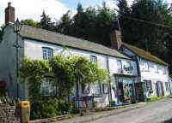

Orleton Village Shop

& Post Office

Shop Post Office

Mon- Fri 0745-1800 0745-1800

Sat 0830-1230 0830-1230

Sun 0830-1230 Closed

Changing buses or waiting for the 409?

Why not treat yourself to a Barista Coffee, Milk Shake or Smoothie?

Sample our range of delicious pastries and savouries











**Orleton Parish Council**

There is no formal Parish Council Report this month.

However, there was a very “interesting” meeting on Thursday 15th January details of which may be obtained from any of the approximately sixty people in attendance.

At the time of going to press we understand that there have been significant developments subsequent to that meeting and there are ongoing matters which we hope will be covered by a Report from the Parish Council in the March edition of this publication

Orleton Church & Chapel News

After the celebrations of Christmas, January has been a relatively quiet time.

In addition to the usual services and meetings, on 11th January, we had the joy of a Family Epiphany Service where we had a drama to Meet the Kings, followed by party games and a party tea.

On 25th January, we celebrated Jesus’s gathering of his disciples through craft activities (followed by more activities and snacks!).

Moving into February, we see the start of Lent. Look out for details elsewhere in this issue of the Lent activities:

* Pancake Racing: Sunday 15th February, 3pm at The Maidenhead;
* Ash Wednesday service: 18th February, 6.30pm, St George’s Church
* Lent discussion group: Wednesdays 25th February, 4th March, 11th March, 18th March, and 25th March, all at 7.30pm in Chapel

Details of our Easter services will be in March’s newsletter, and on posters round the village.

Updates on our other activities, including an update on our Family Services, the Orleton History Group, Singing for Fun, Open the Book, food bank donations, and the 100 Club winners, can be found in our full newsletter, at: https://stgeorgesorleton.org.uk/news/news , and click on ‘Church & Chapel News’.



For further information about Church, Chapel, services or activities, or if you would like to get

involved either socially or as a member of the congregation then please contact:

Matthew Burns (Vicar, St George’s): 01568 614399,

teamvicarwest@leominsterteam.org.uk

Rev Denise Hargreaves (Methodist Minister): 01584 318628, dkah26@gmail.com, Ludlow Church

Office 01584 879233

Also, why not check out the St George’s website: https://stgeorgesorleton.org.uk.



Orleton Good Neighbour Scheme

The Good Neighbour Scheme supports our community using a team of volunteers to help people who are experiencing difficulty in their own homes essentially, by just doing things that good neighbours do for each other.

Examples of how the scheme can help:

* Fetching prescriptions
* Occasional lifts to the surgery or hospital
* Shopping and running errands, such as posting a letter.
* Practical tasks around the home, such as changing a light bulb or hanging a picture

**Contact Number 07467 535503**



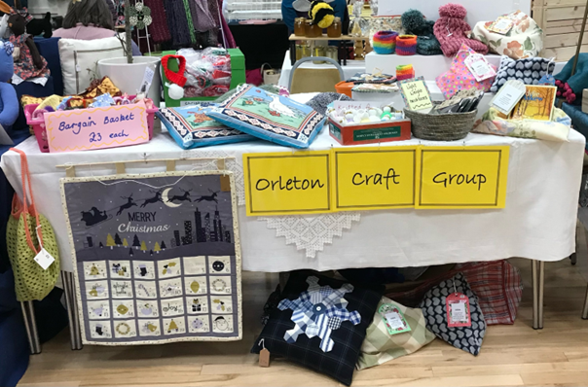

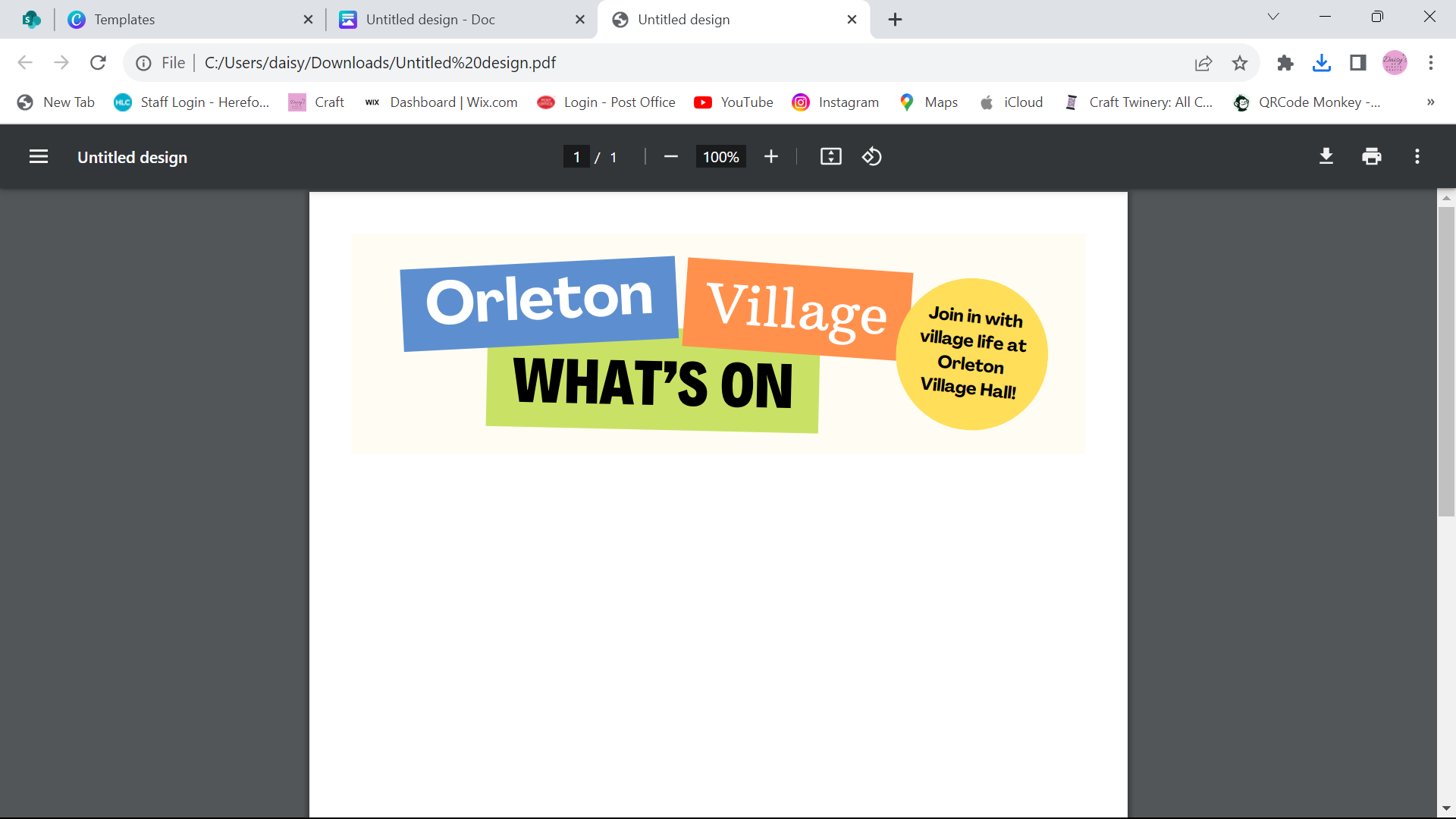

**Happy New Year from Orleton Village Hall**

**Dates for your diary…**

**Saturday 7th March** – Ludlow Concert Band return to the Village Hall

**The REGULARS Monday – Thursday …**

**Orleton Toddlers** Every Monday morning 10-11:45am

Contact: Bethan 07534 726222 or Charlotte 07964 981036

**Orleton WI** 2nd Monday of the month, October to March at 2:30pm

Contact: Sue Copson [susancopson934@gmail.com](mailto:susancopson934@gmail.com)

**Tai Chi** Every Tuesday 10:15-11:15am Contact: Rose Jacks jacks3@btinternet.com

**Rainbows** Every Tuesday in term time 4:30-5:30pm

Contact Kaye Harrison [kayemharrison@yahoo.co.uk](mailto:kayemharrison@yahoo.co.uk)

**Gardening Club** Last Tuesday of the month 7:30-9:30pm

Contact: Monica 01568 613361 [orletongc@hotmail.co.uk](mailto:orletongc@hotmail.co.uk)

**Yoga** Every Tuesday evening 6:30-7:30pm (Commences again in September)

Contact Rosie 07834 851656

**Coffee Morning** Every Wednesday at 10:30am-12:00 (Closed in August)

Contact: Cathy Hardwick [cathy.hardwick@hotmail.co.uk](mailto:cathy.hardwick@hotmail.co.uk)

**Library**  Last Wednesday of the month at Coffee Morning 10:30-11:45am

Contact: Sue Rogers 01584 831514

**Sequence Dancing** 3rd Wednesday of the month – 2-3pm

Contact: Amy Whitby [amyelwynwhitby@gmail.com](mailto:amyelwynwhitby@gmail.com)

**Evergreens** Last Thursday of the month – 2-4pm

Contact: Sue Turner [sue.a.turner@gmail.com](mailto:sue.a.turner@gmail.com)

**Craft Group** 1st and 3rd Thursday of each month 1:30-4:30pm (No sessions in August)

Contact Sue Turner 01584 831324 [sue.a.turner@gmail.com](mailto:sue.a.turner@gmail.com)

**Table Tennis** Every Thursday at 7:30pm Contact: Geoff Lewin [geoffnlewin@gmail.com](mailto:geoffnlewin@gmail.com)

**Hall available for private bookings**

**Contact Barry Gandy 01568 780583 or** [**bookings@orletonvillage.co.uk**](mailto:bookings@orletonvillage.co.uk)

**To include your event or amend an entry in the Dairy,**

**Please Email** [**orletonhandmade@gmail.com**](mailto:orletonhandmade@gmail.com) **by the 12th of the month**

All entries are, as far as we know, correct at the time of going to print.

**Contacts**

|  |  |  |  |
| --- | --- | --- | --- |
| Allotments Assoc | Nick Ford |  | 01584 875834 |
| Art Group | Geoff Trotter | Geoffrey.a.trotter@gmail.com |  |
| Caring for God’ Little Acre | Barbara Mark |  | 01568 780842 |
| Church Wardens | Liz Mackay  John Berry |  | 07484 679671  01568 780321 |
| Doctors |  |  | 01584 831300 |
| Evergreens | Sue Turner |  | 01584 831324 |
| Gardening Club | Nick Russel |  | 01568 780678 |
| Good Neighbour Scheme |  |  | 07467 535503 |
| Herefordshire Councillor | Cllr. Dan Hurcomb | dan.hurcomb@herefordshire.gov.uk | 07792 882147 |
| Land Drainage Group | David Lane |  | 01568 78036 |
| Orleton Footpath Maintenance Volunteers | Matin Bradford | emimart@hotmail.com | 01568780151 |
| Orleton Relief in Need | Barry Rogers |  | 01584 831514 |
| Orleton Junior Football Club | Mel Williams | cherry.brook@me.com | 07511 920515 |
| Orleton Toddlers | Bethan Jenkins | Bethan.I.edwards@hotmail.co.uk | 07534 726222 |
| Orleton Young Farmers Club | Bell Beaumont | orleyonyfc@hotmail.com |  |
| Parish Council |  | clerk@orleton-pc.gov.uk |  |
| Pre-School | Tara Morris |  | 01568 780143 |
| Primary School |  | admin@orleton.hereford.sch.uk | 01568 780366 |
| Primary School PTA | Nicola Goodman | nicolagoodman1989@gmail.com |  |
| Rainbows | Carly Morgan |  | 07788 236628 |
| Recreation Association | Graham Shaw |  | 01568 780783 |
| Village Hall |  | bookings@orletonvillage.co.uk | 01568 780583 |
| WI | Sue Copson |  | 01568 780956 |